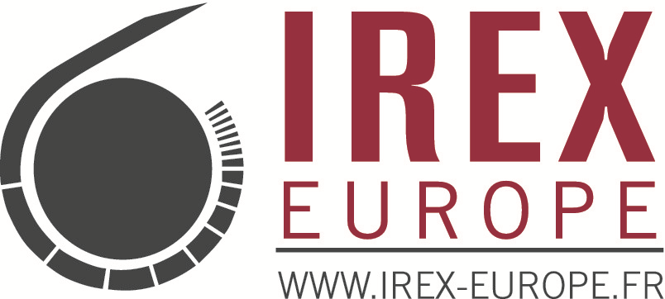

MEDIA TRAINING
Promotion of Media Literacy through the Libraries

Call for application for Librarians

IREX Europe is pleased to announce a training opportunity open to Moldovan librarians from all raions and Transnistria who wish to learn more about media and to enhance their skills on media reporting. Librarians taking part in this Training for Trainers (ToT) will be involved afterwards in teaching to their peers or their community the skills learned. We offer to the most interested librarians the opportunity to be part of a 3 day Training, held by the American trainer Carol Lange in the period March 30 April 1 and April 2-4 (pending number of applications received; this second training will be in Russian if we receive at least 12 applications).

During the training, the participants will learn how to distinguish a good news from a bad one, the structure of the news and how to write one for their website or local newspaper. They will also be able to recognize bias information and prevent manipulation through media. They`ll be provided with examples and models of media materials which will help them grasp a better understanding of the media environment in Moldova.

At the end of the training the participants will be encouraged to adopt critical thinking and approach towards media and to share the knowledge acquired during the training with other members of the community through the organization of discussions, trainings or other events.
As a continuation of the training, we plan to create and develop several MEDIA CORNERS in libraries (with financial support from IREX Europe).

Past training implementation experience and good communication skills will be considered an asset

The deadline for application is February 15th.

The selection of librarians will take place in the following week. All the librarians will be informed about our decision. The selected ones will be contacted supplementary.

All the costs related to the training (travel costs, accommodation, meals) are fully covered by the program. At the end all participants will receive a certificate of participation.

Contact: If you are interested please send your CV and application form to Daniela Galai, Program Coordinator, at dgalai@irexeurope.eu by the 15th of February.

If you have questions, you can call Daniela on mob. phone 068684220.

The training is part of the IREX Europe project Strengthening Independent Media and Media Literacy in Moldova, financed by DRL ( Bureau of Democracy, Human Rights, and Labor ) and in partnership with IREX Moldova program “Novateca”.

About IREX Europe is a non-profit, non-governmental organization providing innovative programs to improve the quality of education, strengthen independent media, foster pluralistic civil society development, and reduce conflict. To learn more, please visit: www.irex-europe.fr

_____________________________________________________________________
IREX EUROPE
202 STEFAN CEL MARE BLV, KENTFORD BUILDING, 8th FLOOR, MD-2004, CHISINAU, MOLDOVA
022/22.29.92
DGALAI@IREXEUROPE.EU | WWW.EUROPE-IREX.FR

